**Initial Contact of New Company**

The goal for the cold call is to determine if they’re an interested customer and that they meet our requirements. We would like companies with 5 or more employees that are not currently using an electronic time clock system. They may have a paycheck solution, but we are offering automated timesheets which can be used in conjunction with their paycheck software.

During the call, you will be gathering information needed to create a site and calculate their return (ROI Calc). Below you will find some helpful guidelines to accomplishing these tasks.

**Setup New Site at** [**http://www.simpsf.com/site/?signup=1**](http://www.simpsf.com/site/?signup=1)

Collect 3 pieces of information to set up their site.

1. Company Name (This we should have before call)
2. Payroll/Owner Name (If possible, get this before call)
3. Email Address

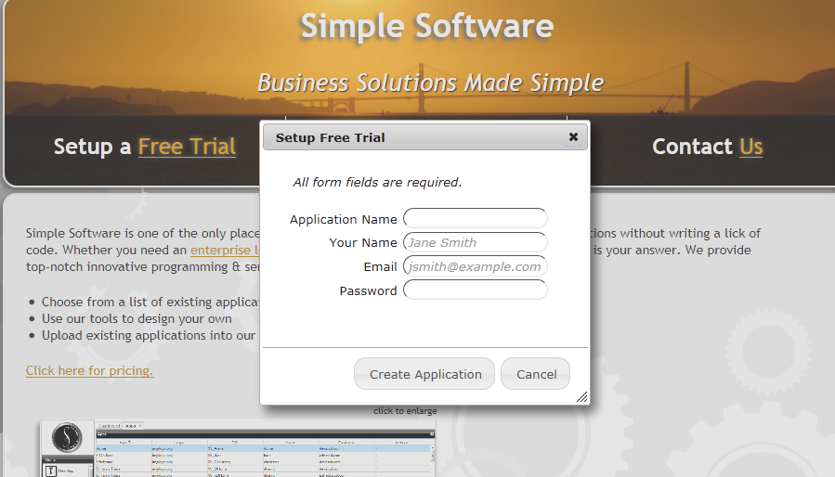

Use the information above to fill out the form:

* Application Name = Company Name (Use Capitalization and spaces. For example: “Simple Software”)
* Your Name = Payroll/Owner Name
* Email = Their Email address
* Password = simple1

**Employee**

Add “Employee” record to system, using email address above, in order to demo Timeclock

1. Login to site using email address and “simple1” as password
2. Click on Administrator, then click on Employee
3. Click on New button
4. Enter information below and then click save
   1. Make sure you fill out the fields properly and set the record to Active!!!
5. Have customer log in using the email address

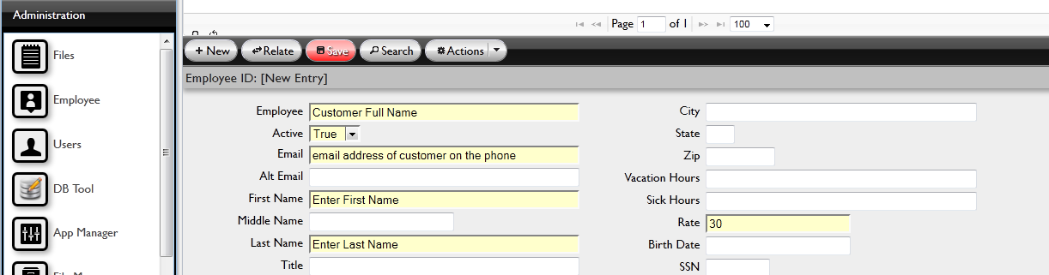

If you entered everything properly, log out then log back in to sync user to employee. If you forgot to set employee to active, they will not be able to clock in!!

**TimeClock**

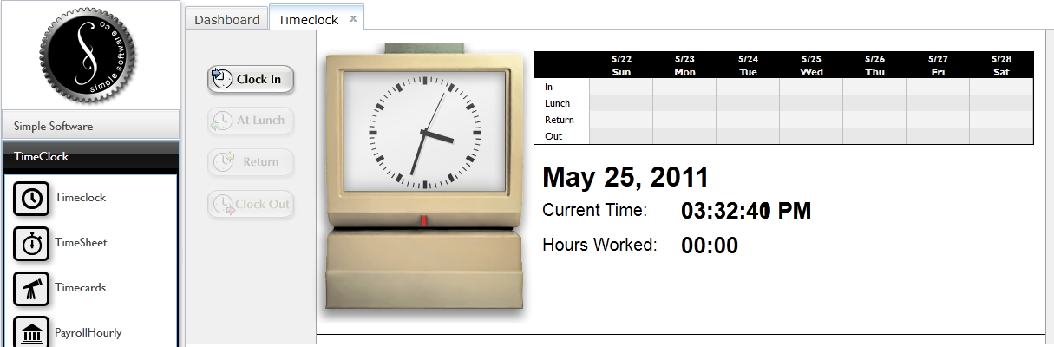

Click all of the buttons starting with ‘Clock In’ in order to generate some demo data. Once you’ve ‘Clock Out’ for the day, the buttons should all be grey. Continue below.

**TimeSheet**

TimeSheet allows the employee to view their timesheet without making changes.

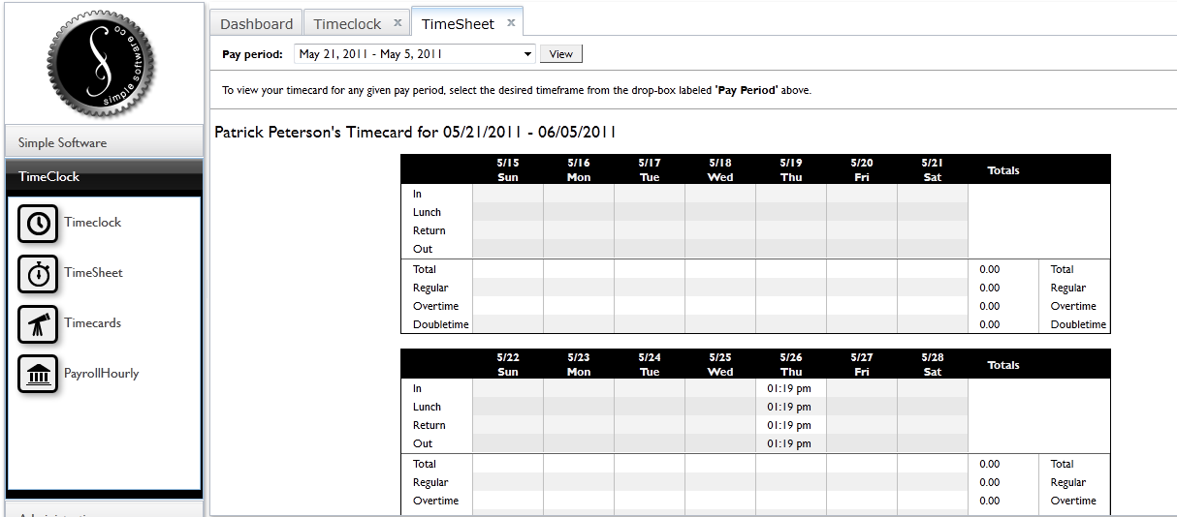

Timecards

Managers can use Timecards to make changes to an employee’s punches or to add one if an employee forgot to punch in or out. Time is entered in 100 parts of an hour. 12:50p = 12:30p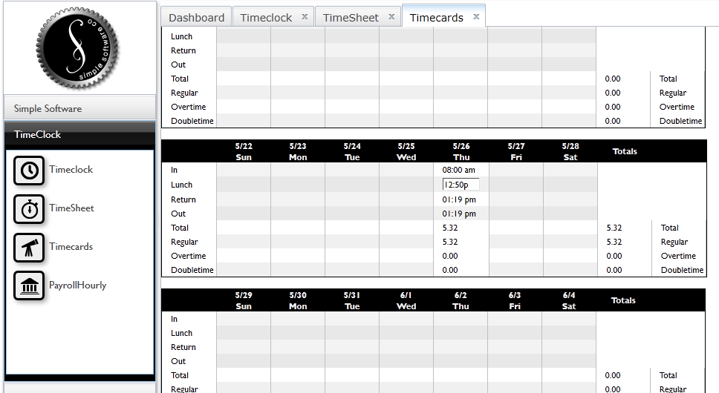

**Payroll**

Generating payroll is as simple as selecting the pay period and clicking a button. The system will download a spreadsheet to your local computer which will have a breakdown by employee.

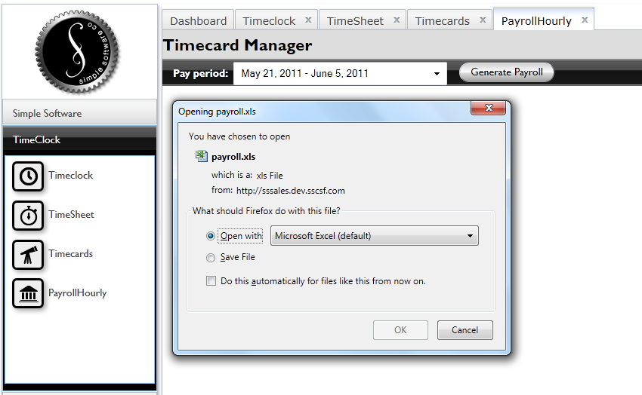

The calculations are based on the rate entered into the Employee record.

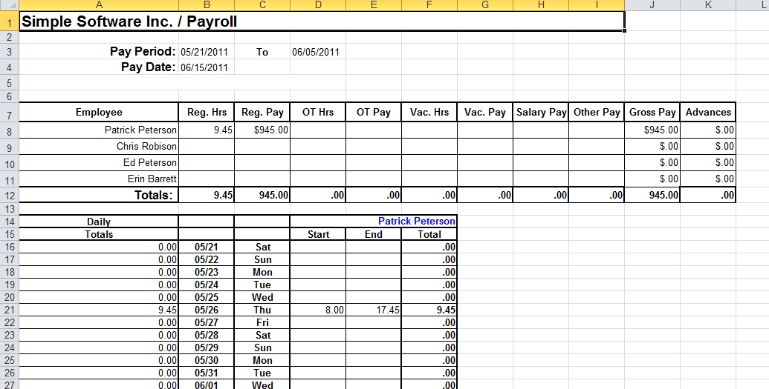

ROI Calculator

Collect some information for our Return on Investment calculator which will help point out their potential savings.

1. Number of employees
2. Time it currently takes to do payroll
3. Average salary of their employees

<http://www.simpsf.com/site/3w/applications/return-on-investment-calculator/>

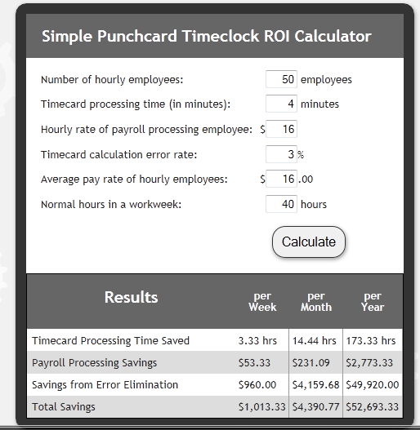

FAQ

* Q -How much?
  + It’s usually $500 for setup but is currently being offered at 50% off. This price includes adding all employees and training. We only charge $10 per employee, per month. However, currently we’re offering a 35% discount to customers that pay a year in advance. That works out to $6.50 per employee per month.
* Q – Who/What are we?
  + We are an online company like Salesforce.com that offers monthly subscription to any of our applications. Since we’re a subscription service, your monthly charge covers all maintenance and backups as well as free upgrades. You’ll never have to worry about buying hardware, software or paying someone to manage your IT. We back up your database nightly and move it offsite. You also get access to all of our online tools which allow you customize and run applications yourself. If you’d like, our rep can show you how to use the tools to run your business. Timeclock is an easy way to immediately save your company money, but we know that once you start using our tools, you’ll stop paying for other software.
* Q – How do my employees clock in/out?
  + Each employee is given a username and password to your website. From any internet ready computer, they simply login then clock in or out. The rest is automatically tracked and calculated.
* Q – What if they miss a punch?
  + We have a timecard that allows the employees supervisor to edit make changes. The employee may view the timecard, but not edit it. This has proven a very successful technique and everyone can see how many hours they have worked before payroll is generated.
* Q – How is payroll generated?
  + It’s as simple as selecting a pay period and clicking a button. A spreadsheet is then downloaded to your computer which has a breakdown of every employee’s hours and the amount they should be paid. This can then be uploaded to your payroll system once it’s been approved. The hard part has been taken care of by having your employee’s clock in and out through our software.
* Q – How long does it take to set up?
  + We can have your site up in just a few minutes. I can have an account rep come by your office as soon as tomorrow to add your employees and train you how to use it. We’ve found that this usually takes from 30 minutes to 1 hour depending on the size of your company. How many employees do you have?

**Example Call**

Hi, this is ______ with Simple Software. Can I speak to (owner’s name)?

Hi _____, I’m an account rep for Simple Software based in San Francisco. We’re currently offering a 50% discount for our online Time Clock. Are you currently using any kind of payroll software?

* If yes – Does it generate your timesheets or simply pay your employees? (most companies have payroll software like ADP but don’t have an electronic Time Clock that will automatically generate timesheets)
* If no – Do you generate your timesheets manually? Roughly, how many hours do you spend a week on payroll?

The American Payroll Association also estimates an average of 23 to 49 minutes a day, PER EMPLOYEE, are lost due to long lunches, breaks, early departures, etc.

How many employees work for “Company Name”?

Number of Employees: __________

--------Refer to ROI Calc-------

Based on the number of employees, our ROI calculator estimates your savings would be (Refer to Total Savings in ROI). What is your email address so I can send you these figures?

Email: ________

We usually charge $500 for setup but we’re currently offering 50% off. This price includes setup and training. We only charge $10 per employee, per month. However, currently we’re offering a 35% discount to customers that pay a year in advance. That works out to $6.50 per employee per month. You can choose this option when you receive your first monthly bill.

-------Refer to Setup New Site------

I’m going to setup your website now while I have you on the phone. If you open your email, you will see an email from Simple Software. This email contains your new website and your login. I’m setting your password to “simple1”. Let me show you how easy it is to use our system.

Closing

I’m going to send a representative over to your office to add the rest of your employees and train you on the new system. I currently have tomorrow at 3p available. Does this time work for you?

* If yes – Ok, great. Can I get your physical address?
* If no – what time works best for you?

For your meeting, we will need a list of employees and their hourly rate. We will also need a check in the amount of $250, made out to “Simple Software, Inc.”. This covers the setup and training of your payroll manager. The monthly service charge will be due at the end of each month.

Support is always free and you will be assigned a support technician once we complete the setup.

Do you have any questions for me at this time?

Just to confirm, we will be sending Patrick Peterson out to (Company Address) to meet with (Contact Name) on (Date) at (Time). He will set you up and show you how to use our system. Feel free to have him show you all of the tools that come with your new system.

Let me give you my contact information just in case you have any questions.

My name, email address, phone number and our address is:

Simple Software, Inc.

1232 Market Street, Suite 120

San Francisco, CA 94102